ABIRAMI K

230701008 CSE-A

EXP NO: 7 IPC USING SHARED MEMORY

PROGRAM

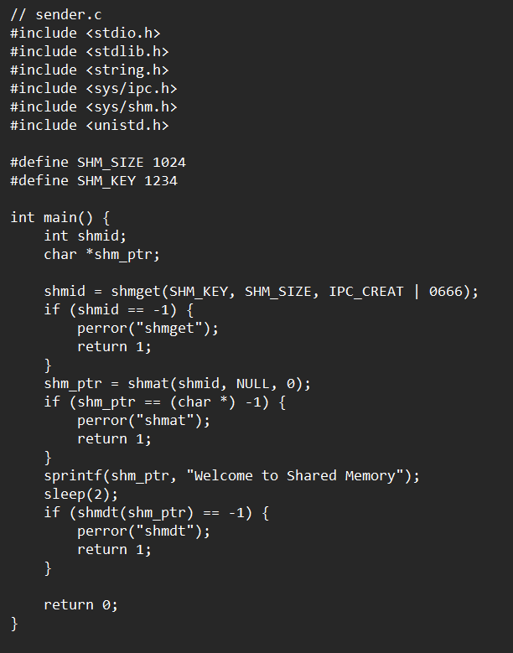

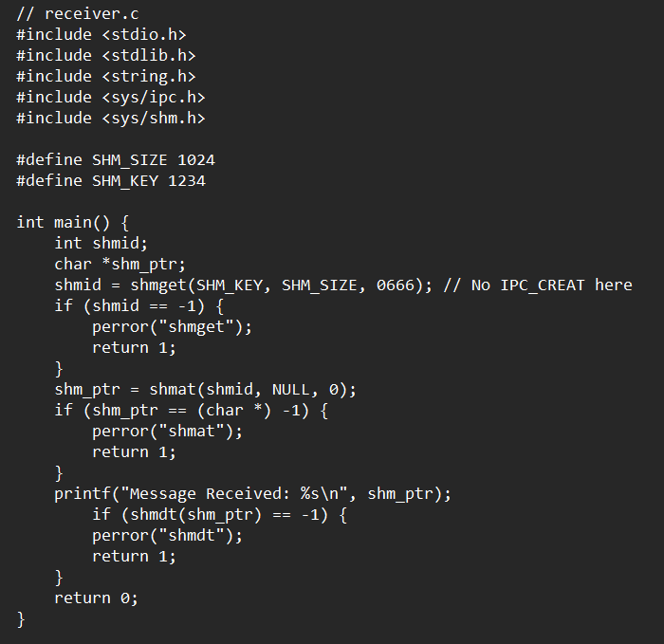

OUTPUT

